Chile Earthquake Prediction Using Artificial Neural Networks

# 1. Introduction

Chile is one of the most seismically active countries in the world due to its location along the Pacific Ring of Fire. This project aims to build a predictive model using Artificial Neural Networks (ANN) and LSTM to forecast earthquake magnitudes in Chile. A web-based dashboard was developed to visualize historical and predicted seismic data to assist in early awareness and preparedness.

# 2. Dataset Description

The dataset used contains records of earthquakes in Chile, including their magnitudes and dates. The dataset spans several years, capturing the variability and unpredictability of seismic activity in the region. Data preprocessing steps included date parsing, normalization, and splitting for training and testing.

# 3. Methodology

Two models were implemented:  
- A basic Artificial Neural Network (ANN)  
- A Long Short-Term Memory (LSTM) model  
The ANN model showed better performance in capturing the high variability in magnitude data. The LSTM model, in contrast, was less effective due to the non-seasonal and highly noisy nature of the data.

# 4. Model Architecture

The ANN model consists of the following layers:  
1. Input Layer: Accepts the normalized magnitude values  
2. Dense Layer 1: 128 neurons, ReLU activation  
3. Dense Layer 2: 64 neurons, ReLU activation  
4. Dense Layer 3: 32 neurons, ReLU activation  
5. Output Layer: 1 neuron, Linear activation  
This architecture enables the model to learn complex patterns in earthquake data for regression purposes.

# 5. Evaluation Metrics

The performance of the models was measured using:  
- Mean Squared Error (MSE)  
- Root Mean Squared Error (RMSE)  
- R² Score (Coefficient of Determination)  
The ANN model achieved a higher R² score, indicating better performance in tracking actual magnitude variations.

# 6. Results & Visualizations

Visualizations demonstrate the effectiveness of the ANN model compared to LSTM. The ANN predictions closely follow the true magnitudes, whereas the LSTM model fails to capture the magnitude spikes.

# 7. Demo and Dashboard

The dashboard features the following sections:  
- Historical Magnitude Trends  
- ANN-based 14-day Magnitude Forecasts  
- Comparison of LSTM vs ANN Predictions  
- Geographic Earthquake Distribution using clustering

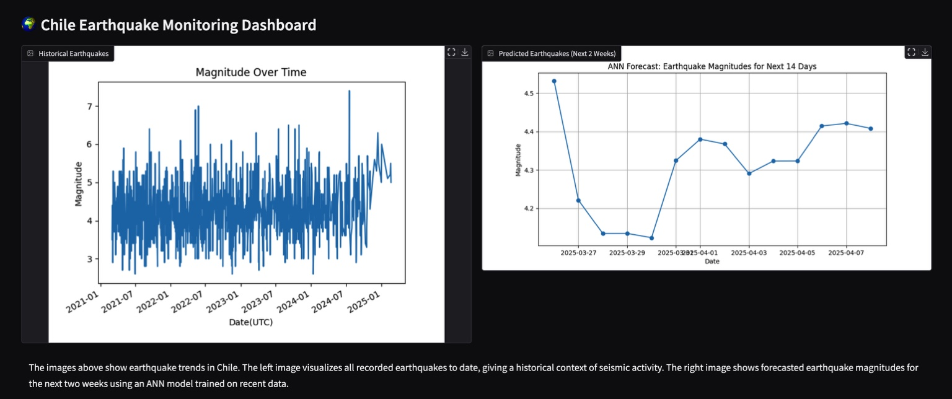

Figure: Visual representation from dashboard.

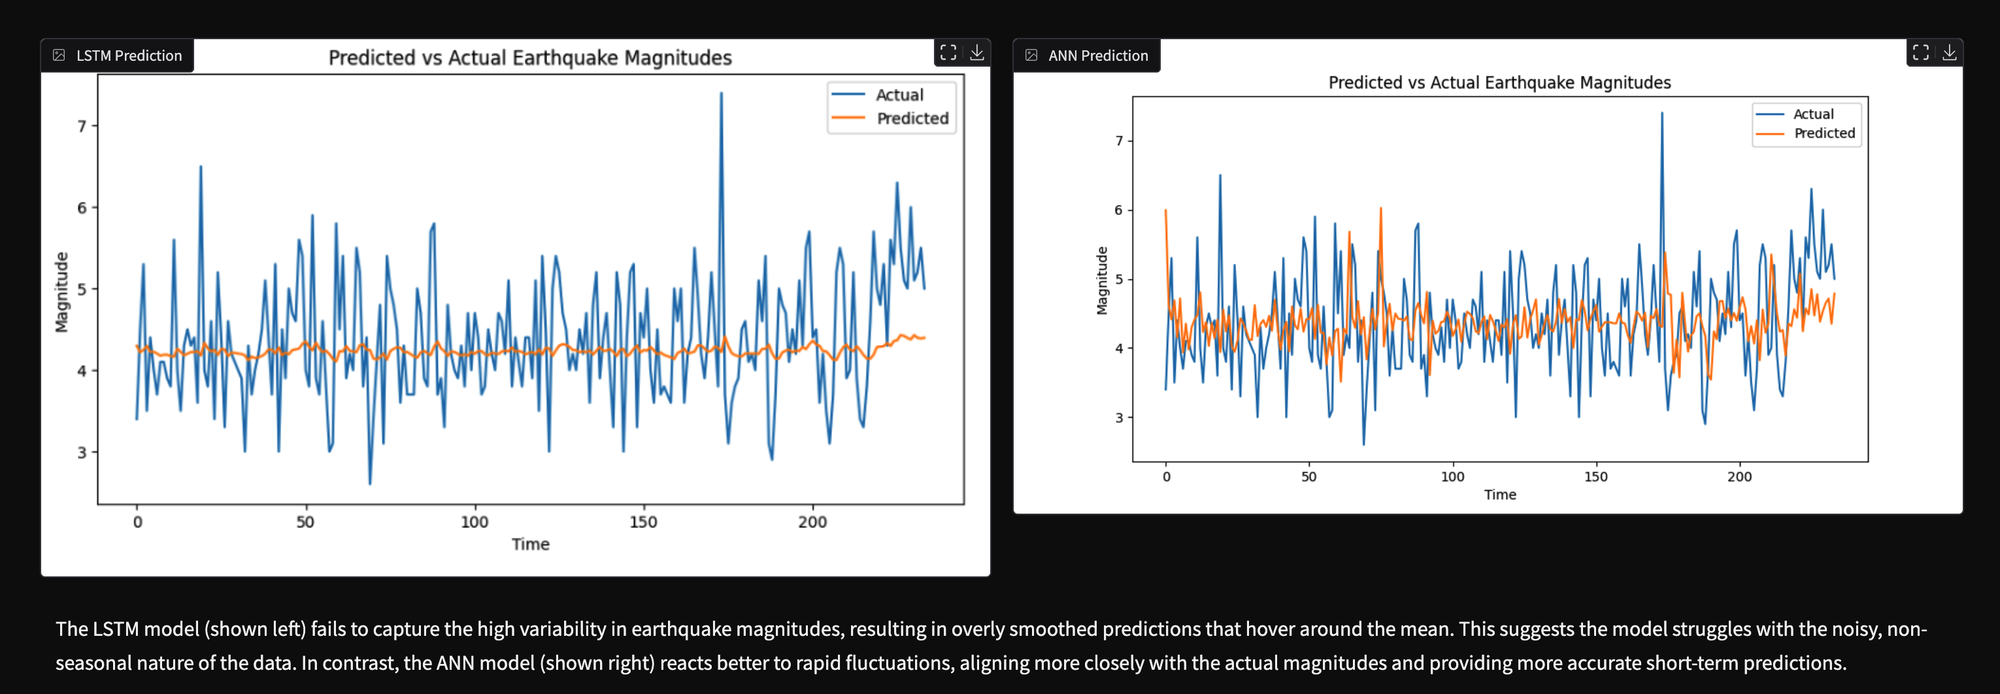

Figure: Visual representation from dashboard.

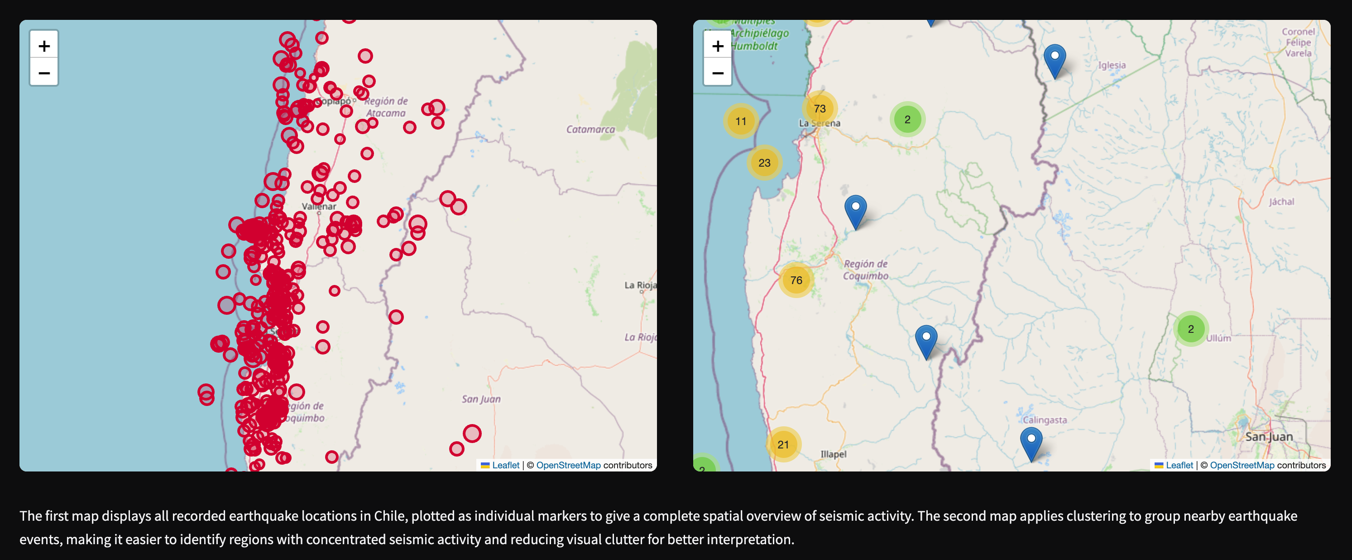

Figure: Visual representation from dashboard.

# 8. Conclusion

This project demonstrates the feasibility of using ANN for short-term earthquake magnitude prediction in Chile. Despite data noise and unpredictability, ANN outperformed LSTM and provided valuable insights. The dashboard helps present results in an accessible way to aid understanding and monitoring.